PRN: 260740150004

260740150018

Day 1 : Lab Exercises — Foundations of Parallel Computing & Concurrency

Exercise 1: JSON Configuration Manager
Topic: Data Serialization with JSON

Problem Statement
Write a program ex01_config_manager.py that manages application configuration using JSON serialization.
Your program should:
- Define a Python dictionary representing a parallel computing job configuration:

config = {
"job_name": "matrix_benchmark", "num_workers": 4,
"chunk_size": 1000,
"timeout_sec": 30.0, "retry_on_failure": True,
"input_files": ["data_part1.csv", "data_part2.csv", "data_part3.csv"],
"output_dir": "/results/run_001", "parameters": {
"algorithm": "strassen", "precision": "double"
}
}
- Save this configuration to a file called job_config.json.
- Load the configuration back from the file.
- Modify a value (e.g., change num_workers to 8) and save it again.
- Pretty-print the final configuration to the console.
Hints & Guidelines
  - Use json.dump() with indent=4 for human-readable output.
  - Use json.load() to read the file back into a dictionary.

  - After modifying the loaded dictionary, write it back using json.dump() again — JSON files are fully overwritten, not appended.
  - Verify that the file on disk reflects your changes by reading it one final time.

Best Practices
  - Always use context managers (with open(...) as f:) for file I/O — they guarantee the file is closed even if an error occurs.
  - Add error handling with try/except for FileNotFoundError and json.JSONDecodeError
when loading files.
  - Use meaningful key names — the config file should be self-documenting.
Code:
import json

# 1. Create the dictionary
config = {
"job_name": "matrix_benchmark",
"num_workers": 4,
"chunk_size": 1000,
"timeout_sec": 30.0,
"retry_on_failure": True,
"input_files": ["data_part1.csv", "data_part2.csv", "data_part3.csv"],
"output_dir": "/results/run_001",
"parameters": {
"algorithm": "strassen",
"precision": "double"
}
}

# 2. Save it to a file called job_config.json
with open("job_config.json", "w") as f:
json.dump(config, f, indent=4)

# 3. Read the file back
with open("job_config.json", "r") as f:
loaded_config = json.load(f)

# 4. Change num_workers to 8 and save it again
loaded_config["num_workers"] = 8
with open("job_config.json", "w") as f:
json.dump(loaded_config, f, indent=4)

# 5. Read it one final time and print it nicely
with open("job_config.json", "r") as f:
final_config = json.load(f)
print(json.dumps(final_config, indent=4))

Output:
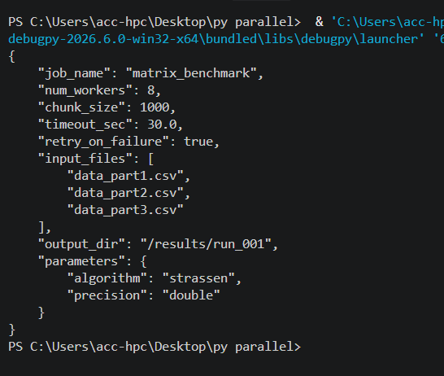

Exercise 2: Pickle a Task Queue
Topic: Object Serialization with Pickle

Problem Statement
Write a program ex02_task_queue_pickle.py that demonstrates pickling a queue of computational tasks.
- Define a ComputeTask class with the following attributes:
task_id (int)
operation (str) — e.g., "square", "cube", "factorial"
input_value (int)
result (initially None)
A method execute() that computes the result based on the operation and stores it in
self.result.
A repr method for clean printing.
- Create a list of 5 ComputeTask objects with different operations and input values.
- Execute only the first 2 tasks (call .execute() on them).
- Pickle the entire list to a file task_queue.pkl.
- Unpickle the list from the file and print all tasks — verify that:
The first 2 tasks show their computed results.
The remaining 3 tasks still show result=None.
- Execute the remaining tasks on the unpickled list and print the final state.
Hints & Guidelines
  - For "factorial", use math.factorial() from the standard library.
  - Remember: pickle preserves the exact state of objects — completed tasks remain completed, pending tasks remain pending.

  - The class definition must exist when you unpickle — in this exercise, pickling and unpickling happen in the same script, so this is automatic.

Best Practices
  - Use "wb" mode for writing pickle files and "rb" for reading — pickle is a binary format.
  - Never unpickle files from untrusted sources in real applications.
  - Clean up temporary files at the end of your program using os.remove().

Code:
import math
import pickle
import os

# 1. Define the ComputeTask class
class ComputeTask:
def __init__(self, task_id, operation, input_value):
self.task_id = task_id
self.operation = operation
self.input_value = input_value
self.result = None

def execute(self):
if self.operation == "square":
self.result = self.input_value ** 2
elif self.operation == "cube":
self.result = self.input_value ** 3
elif self.operation == "factorial":
self.result = math.factorial(self.input_value)

def __repr__(self):
return f"Task(id={self.task_id}, op='{self.operation}', value={self.input_value}, result={self.result})"

def main():
filename = "task_queue.pkl"

# 2. Create a list of 5 ComputeTask objects with different operations and values
tasks = [
ComputeTask(1, "square", 4),
ComputeTask(2, "cube", 3),
ComputeTask(3, "factorial", 5),
ComputeTask(4, "square", 6),
ComputeTask(5, "cube", 2)
]

# 3. Execute only the first 2 tasks
print("Executing the first 2 tasks...")
tasks[0].execute()
tasks[1].execute()

# 4. Pickle the entire list to a file using binary write mode ("wb")
print(f"Saving tasks to '{filename}' using pickle...")
with open(filename, "wb") as f:
pickle.dump(tasks, f)

# 5. Unpickle the list from the file using binary read mode ("rb")
print("Loading tasks back from the pickle file...\n")
with open(filename, "rb") as f:
loaded_tasks = pickle.load(f)

print("--- State After Unpickling ---")
for task in loaded_tasks:
print(task)

# 6. Execute the remaining tasks on the unpickled list
print("\nExecuting the remaining tasks...")
for task in loaded_tasks:
if task.result is None:
task.execute()

print("\n--- Final State of All Tasks ---")
for task in loaded_tasks:
print(task)

# Clean up temporary pickle file
if os.path.exists(filename):
os.remove(filename)
print(f"\nCleaned up temporary file: {filename}")

if __name__ == "__main__":
main()

Output:
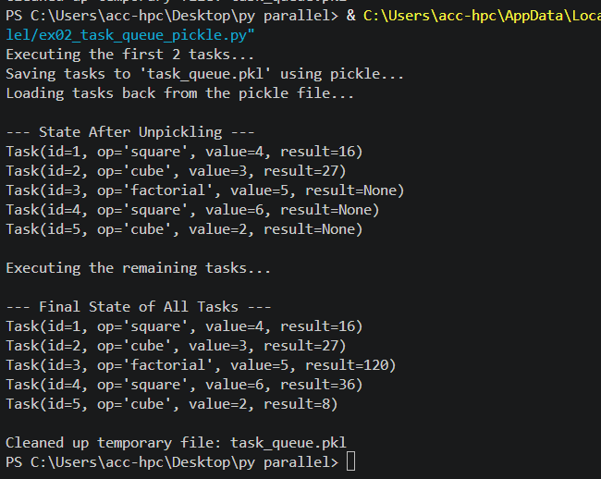

Exercise 3: Parallel File Word Counter
Topic: Multiprocessing — Process and Pool

Problem Statement
Write a program ex03_parallel_word_counter.py that counts words in multiple text files using both sequential and parallel approaches.
- Generate test data: Create 6 text files (file_0.txt through file_5.txt), each containing 5,000–10,000 random words. You can generate random words by repeating a list of sample words:

import random
words = ["python", "parallel", "computing", "process", "thread", "memory", "data", "algorithm", "performance", "speedup"]
content = " ".join(random.choices(words, k=8000))
- Write a function count_words(filepath) that reads a file and returns a tuple (filepath, word_count).
- Sequential run: Call count_words() on each file in a loop and measure the time.
- Parallel run: Use multiprocessing.Pool.map() to count words across all files simultaneously.
Measure the time.
- Print the results from both runs (they should be identical) and calculate the speedup.
- Clean up — delete the generated test files.
Hints & Guidelines
  - Use len(content.split()) to count words in a string.
  - Use time.time() before and after each run to measure elapsed time.
  - The files are small, so the speedup may be modest or even negative due to process creation overhead. That's an important observation in itself!
  - To make the parallel version show a speedup, add a small artificial delay in count_words() using
time.sleep(0.5) to simulate reading from a slow disk or network drive.

Best Practices

  - Always guard your multiprocessing code with if name == " main ":.
  - Define worker functions at module level (not inside main() or inside another function) — this is required on macOS and Windows.
  - Use with Pool(...) as pool: for automatic cleanup of worker processes.
Code:
import multiprocessing
import os
import time

# Worker function to count words in a file
def count_words(filepath):
time.sleep(0.5) # Simulate a slow disk read delay
with open(filepath, "r", encoding="utf-8") as f:
words = f.read().split()
return filepath, len(words)

if __name__ == "__main__":
files = [f"file_{i}.txt" for i in range(6)]

# 1. Create sample test files
for name in files:
with open(name, "w", encoding="utf-8") as f:
f.write("python parallel computing data performance " * 1500)

# 2. Sequential Run
start_seq = time.time()
seq_results = [count_words(f) for f in files]
seq_time = time.time() - start_seq
print(f"Sequential Time: {seq_time:.2f} seconds")

# 3. Parallel Run using Pool
start_par = time.time()
with multiprocessing.Pool() as pool:
par_results = pool.map(count_words, files)
par_time = time.time() - start_par
print(f"Parallel Time: {par_time:.2f} seconds")

# 4. Print results & speedup
print("\nResults:", par_results)
print(f"Speedup: {seq_time / par_time:.2f}x")

# 5. Clean up files
for name in files:
if os.path.exists(name):
os.remove(name)

Output:
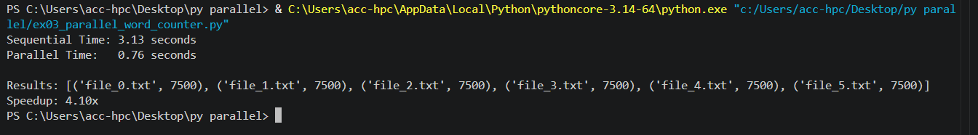

Exercise 4: Matrix Operations with Threads
Topic: Multithreading — Basics and Shared Memory

Problem Statement
Write a program ex04_threaded_matrix_ops.py that performs element-wise operations on matrices using threads.
- Create two 5×5 matrices (use nested lists or any structure you prefer):

matrix_a = [[random.randint(1, 10) for _ in range(5)] for _ in range(5)]
matrix_b = [[random.randint(1, 10) for _ in range(5)] for _ in range(5)]
- Create a shared result matrix initialized to zeros:

result = [[0] * 5 for _ in range(5)]
- Write a function add_row(a, b, result, row_index) that computes the element-wise sum of row row_index of matrices a and b, and stores the result in result[row_index].
- Create one thread per row (5 threads total) that each computes one row of the result matrix.
- Start all threads, join them, and print the result matrix.
- Verify correctness by computing the same result sequentially and comparing.
Hints & Guidelines
  - Since threads share memory, all threads can read from matrix_a and matrix_b and write to different rows of result without locks — because each thread writes to a different row (no overlap).
  - If threads were writing to the same row or variable, you would need a threading.Lock.
  - Use threading.Thread(target=add_row, args=(matrix_a, matrix_b, result, i)) for each row i.

Best Practices
  - When threads write to non-overlapping regions of shared data, locks are unnecessary and would only slow things down.

  - Always join() all threads before reading the result — otherwise you may read incomplete data.
  - Print both the expected and actual result to visually verify correctness.

Code:
import random
import threading

# 1. Create two 5x5 matrices with random integers between 1 and 10[cite: 2]
matrix_a = [[random.randint(1, 10) for _ in range(5)] for _ in range(5)]
matrix_b = [[random.randint(1, 10) for _ in range(5)] for _ in range(5)]

# 2. Create a shared result matrix initialized to zeros[cite: 2]
result_matrix = [[0] * 5 for _ in range(5)]

# 3. Write a function to compute the sum of a specific row[cite: 2]
def add_row(a, b, result, row_index):
for col in range(5):
result[row_index][col] = a[row_index][col] + b[row_index][col]

def main():
print("Matrix A:")
for row in matrix_a:
print(row)

print("\nMatrix B:")
for row in matrix_b:
print(row)

# 4. Create one thread per row (5 threads total)[cite: 2]
threads = []
for i in range(5):
t = threading.Thread(target=add_row, args=(matrix_a, matrix_b, result_matrix, i))
threads.append(t)
t.start()

# 5. Start and join all threads before reading the result[cite: 2]
for t in threads:
t.join()

print("\nThreaded Result Matrix")
for row in result_matrix:
print(row)

# 6. Verify correctness by computing the same result sequentially[cite: 2]
expected_matrix = [[matrix_a[i][j] + matrix_b[i][j] for j in range(5)] for i in range(5)]

print("\n Expected Sequential Result Matrix ")
for row in expected_matrix:
print(row)

# Final comparison verification
if result_matrix == expected_matrix:
print("\nVerification Successful: Threaded and sequential results match!")
else:
print("\nVerification Failed: Results do not match.")

if __name__ == "__main__":
main()

Output:
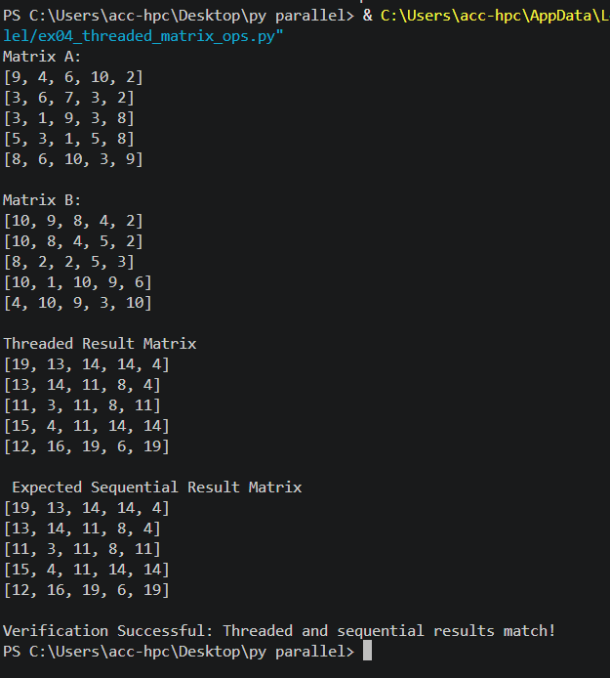

Exercise 5: Producer–Consumer Pipeline
Topic: Thread Communication and Queues

Problem Statement
Write a program ex05_pipeline.py that implements a three-stage processing pipeline using threads and queues:

[Generator] → Queue 1 → [Processor] → Queue 2 → [Writer]
- Generator thread: Produces 20 "raw data" items. Each item is a dictionary:

{"id": i, "value": random.randint(1, 100)}
Put each item into queue_1 with a small delay (0.1s).
- Processor thread: Reads items from queue_1, transforms each item by squaring the "value"
field, and puts the transformed item into queue_2.
- Writer thread: Reads transformed items from queue_2 and collects them into a list. After all items are processed, prints the final list.
- Use None as a sentinel value to signal shutdown through the pipeline:
Generator sends None into queue_1 when done.
Processor passes None into queue_2 when it receives None.
Writer stops when it receives None.
- Start all three threads, join them, and print a summary.
Hints & Guidelines
  - Use queue.Queue() for both queues — they are thread-safe.
  - Each stage should run in its own function, launched as a threading.Thread.
  - The sentinel None propagates through the pipeline, cleanly shutting down each stage in order.
  - Print a message in each stage (e.g., [Generator] produced item 5) so you can observe the interleaved pipeline execution.

Best Practices
  - Bounded queues (Queue(maxsize=5)) apply back-pressure — if the processor is slow, the generator blocks instead of flooding memory.

  - The pipeline pattern is fundamental — it appears in video processing, ETL (extract-transform-load), log processing, and many HPC workflows.
  - Keep each stage simple and focused — a clean pipeline is easy to debug and extend.
Code:
import queue
import random
import threading
import time

def generator(q1):
for i in range(1, 6): # producing 5 items for a quick demo
item = {"id": i, "value": random.randint(1, 10)}
q1.put(item)
print(f"Generator created item: {item}")
time.sleep(0.1)
q1.put(None) # stop signal

def processor(q1, q2):
while True:
item = q1.get()
if item is None:
q2.put(None) # pass stop signal along
break
transformed = {"id": item["id"], "value": item["value"] ** 2}
q2.put(transformed)
print(f"Processor squared value: {item} -> {transformed}")

def writer(q2, results):
while True:
item = q2.get()
if item is None:
break
results.append(item)
print(f"Writer saved item: {item}")

if __name__ == "__main__":
q1 = queue.Queue()
q2 = queue.Queue()
final_results = []

# Create threads
t1 = threading.Thread(target=generator, args=(q1,))
t2 = threading.Thread(target=processor, args=(q1, q2))
t3 = threading.Thread(target=writer, args=(q2, final_results))

# Start threads
t1.start()
t2.start()
t3.start()

t1.join()
t2.join()
t3.join()

print("\nFinal Results:", final_results)

Output:

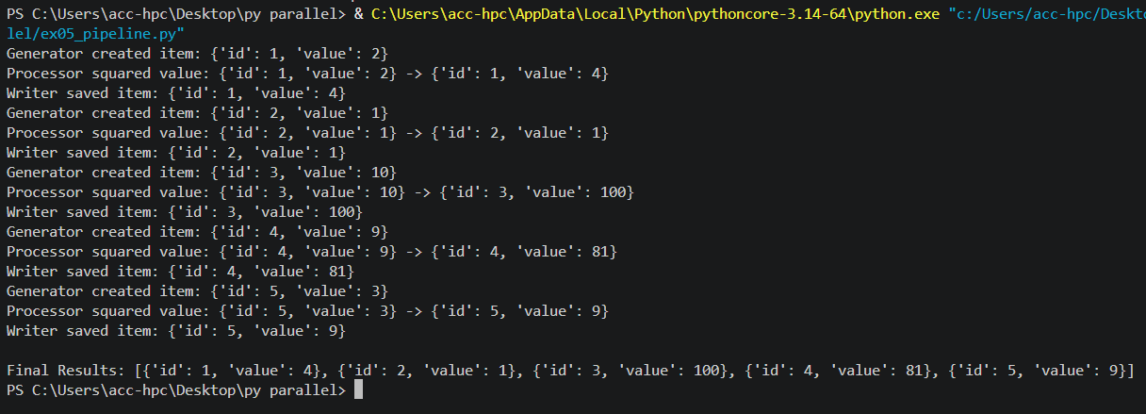

Exercise 6: GIL Impact Experiment
Topic: Global Interpreter Lock — CPU-Bound vs I/O-Bound

Problem Statement
Write a program ex06_gil_experiment.py that empirically demonstrates the GIL's impact by running the same computation with varying numbers of threads and processes.
- Define a CPU-bound function fibonacci(n) that computes the nth Fibonacci number using a naive recursive approach (intentionally slow):

def fibonacci(n): if n <= 1:
return n
return fibonacci(n - 1) + fibonacci(n - 2)
- Define an I/O-bound function download_simulation(url_id) that simulates downloading data:

def download_simulation(url_id):
time.sleep(random.uniform(0.5, 1.5)) # simulated network delay return f"data_from_{url_id}"
- Write a benchmark(func, args_list, mode) function where mode is one of "sequential", "threaded", or "multiprocess". It should:
Run func for each item in args_list using the specified mode.
Return the elapsed time.
- Run the benchmark for both functions across all three modes:
CPU-bound: fibonacci(30) repeated 4 times
I/O-bound: download_simulation(i) for i in range(8)
- Print a clear comparison table showing times and speedups.
Hints & Guidelines
fibonacci(30) takes roughly 0.2–0.5 seconds — long enough to see the GIL effect, short enough to finish quickly.
For threaded mode, create threading.Thread objects.
For multiprocess mode, create multiprocessing.Process objects.
You should observe:

CPU-bound: threads ≈ sequential, processes much faster.
I/O-bound: threads ≈ processes, both much faster than sequential.

Best Practices
- Run the sequential version first to establish a baseline — all speedup numbers are relative to this baseline.
- Use time.perf_counter() for more precise timing than time.time().
- Wrap multiprocessing code in if name == " main ":.
Code:
import time
import threading
import multiprocessing

# 1. Heavy math (CPU-bound)
def heavy_math(n=28):
if n <= 1:
return n
return heavy_math(n - 1) + heavy_math(n - 2)

# 2. Waiting around (I/O-bound, like downloading a file)
def fake_download(x):
time.sleep(0.5)

# Helper function to test timing
def run_test(func, items, mode):
start = time.perf_counter()

if mode == "normal":
for item in items:
func(item)
elif mode == "threads":
threads = [threading.Thread(target=func, args=(item,)) for item in items]
for t in threads: t.start()
for t in threads: t.join()
elif mode == "processes":
procs = [multiprocessing.Process(target=func, args=(item,)) for item in items]
for p in procs: p.start()
for p in procs: p.join()

return time.perf_counter() - start

if __name__ == "__main__":
items_cpu = [28] * 4
items_io = range(4)

print("Heavy Math Test ")
print(f"Normal (one by one): {run_test(heavy_math, items_cpu, 'normal'):.2f} seconds")
print(f"Using Threads: {run_test(heavy_math, items_cpu, 'threads'):.2f} seconds")
print(f"Using Processes: {run_test(heavy_math, items_cpu, 'processes'):.2f} seconds")

print("\n Waiting/Download Test")
print(f"Normal (one by one): {run_test(fake_download, items_io, 'normal'):.2f} seconds")
print(f"Using Threads: {run_test(fake_download, items_io, 'threads'):.2f} seconds")
print(f"Using Processes: {run_test(fake_download, items_io, 'processes'):.2f} seconds")

Output:
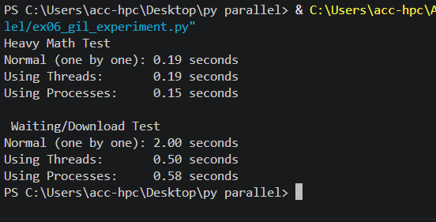

Exercise 7: Race Condition Detector
Topic: Sharing State Between Threads

Problem Statement
Write a program ex07_race_detector.py that demonstrates, detects, and fixes a race condition.
- Part A — Observe the race condition:
  - Create a shared dictionary:

bank_account = {"balance": 1000}
  - Write a function withdraw(account, amount, num_times) that performs num_times
withdrawals of amount from the account:

for _ in range(num_times):
if account["balance"] >= amount: current = account["balance"]
time.sleep(0.0001) # simulate processing delay account["balance"] = current - amount
  - Launch 5 threads, each performing 100 withdrawals of $1.
  - After all threads finish, print the final balance.
  - Expected balance: $1000 − (5 × 100 × $1) = $500.
  - Actual balance will likely be wrong — this is the race condition!
- Part B — Fix with a Lock:
  - Repeat Part A, but protect the withdrawal logic with a threading.Lock.
  - Verify the final balance is exactly $500.
- Part C — Run the experiment 10 times:
  - Run both the unsafe and safe versions 10 times each.
  - Print how many times each version produced the correct result.

  - The unsafe version should fail frequently; the safe version should always succeed.
Hints & Guidelines
- The time.sleep(0.0001) between reading and writing the balance is crucial — it widens the race window so the bug manifests reliably.
- Without the sleep, CPython's GIL may accidentally serialize the operations, masking the bug — but the bug is still there and would surface under different conditions or implementations.
- Use with lock: (context manager syntax) instead of manual lock.acquire() /
lock.release() — it's safer and cleaner.

Best Practices
- Assume every shared mutation is a race until you've protected it with a lock, semaphore, or atomic operation.
- Keep the critical section (code inside with lock:) as short as possible — hold the lock only while accessing shared data.
- Consider using threading.RLock (reentrant lock) if the same thread might need to acquire the lock multiple times (nested calls).
Code:
import threading
import time

# Unsafe withdrawal (causes race condition bug)
def withdraw_unsafe(account):
current = account["balance"]
time.sleep(0.001) # Simulates delay, exposing the bug
account["balance"] = current - 1

# Safe withdrawal (protected by a Lock)
def withdraw_safe(account, lock):
with lock: # Only one thread can change the balance at a time
current = account["balance"]
time.sleep(0.001)
account["balance"] = current - 1

if __name__ == "__main__":
# 1. Unsafe Test
account_1 = {"balance": 100}
threads = [threading.Thread(target=withdraw_unsafe, args=(account_1,)) for _ in range(50)]
for t in threads: t.start()
for t in threads: t.join()
print(f"Unsafe Final Balance (Expected 50): {account_1['balance']}")

# 2. Safe Test with a Lock
account_2 = {"balance": 100}
lock = threading.Lock()
threads = [threading.Thread(target=withdraw_safe, args=(account_2, lock)) for _ in range(50)]
for t in threads: t.start()
for t in threads: t.join()
print(f"Safe Final Balance (Expected 50): {account_2['balance']}")

Output:
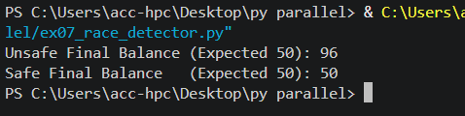

Exercise 8: Process vs Thread Memory Isolation Lab
Topic: Sharing State Between Processes

Problem Statement
Write a program ex08_memory_isolation.py that explores memory isolation between processes and compares different IPC (Inter-Process Communication) mechanisms.
- Part A — Demonstrate isolation:
  - Create a global list shared_log = [].
  - Write a function log_message(msg) that appends msg to shared_log and prints the list's length inside the child.
  - Spawn 3 processes, each calling log_message() with a unique message.
  - After all processes finish, print shared_log from the parent.
  - Observe: The parent's list is empty — each child has its own copy.
- Part B — Share data using multiprocessing.Array:
  - Create a shared array of 10 integers, initialized to 0:

shared_array = multiprocessing.Array('i', 10)
  - Write a function fill_range(arr, start, end, value) that fills arr[start:end] with
value.
  - Spawn 2 processes:
    - Process 1 fills indices 0–4 with the value 1.

    - Process 2 fills indices 5–9 with the value 2.
  - After both finish, print the array from the parent: [1, 1, 1, 1, 1, 2, 2, 2, 2, 2].
- Part C — Share data using multiprocessing.Queue:
  - Create a multiprocessing.Queue.
  - Spawn 4 worker processes, each computing the square of a different number and putting the result (number, square) into the queue.
  - In the parent, read all 4 results from the queue and print them.
Hints & Guidelines
- multiprocessing.Array('i', 10) creates a shared C-style integer array of 10 elements.
Access elements with arr[i].
- multiprocessing.Queue works like queue.Queue but is safe for use between processes (not just threads).
- Queue.get() blocks until an item is available. If you know exactly how many items to expect, call
get() that many times.
- All functions used as process targets must be at module level.

Best Practices
- Prefer Queue or Pipe for message passing between processes — they are simpler and safer than shared memory.
- Use shared memory (Value, Array) only when performance is critical and you need to avoid the overhead of serializing/deserializing data.
- Always use locks when multiple processes write to overlapping regions of shared memory.
Code:
Output:

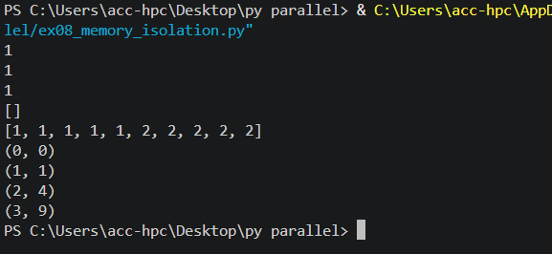

Exercise 9: Parallel Speedup Analyzer
Topic: Performance Evaluation — Speedup, Efficiency, Amdahl's Law

Problem Statement
Write a program ex09_speedup_analyzer.py that measures and visualizes the parallel performance characteristics of a workload.
- Choose a workload: Implement a function monte_carlo_pi(num_samples) that estimates π using the Monte Carlo method:

import random
def monte_carlo_pi(num_samples): inside = 0
for _ in range(num_samples): x = random.random()
y = random.random() if x*x + y*y <= 1.0:

inside += 1 return inside
The estimate of π is: 4 * total_inside / total_samples.
- Sequential baseline: Run monte_carlo_pi(5_000_000) and measure the time.
- Parallel runs: Split 5_000_000 samples across N workers using multiprocessing.Pool.map(). Each worker runs monte_carlo_pi(5_000_000 // N). Sum the inside counts and compute the π estimate.
Run for N = 1, 2, 4, and up to your machine's core count.
- Compute and print for each N:
Parallel time
Speedup = T_seq / T_par
Efficiency = Speedup / N
Amdahl's theoretical speedup (assume serial fraction = 3%)
Gustafson's scaled speedup
- Print the results as a formatted table:

1 | 2.450 | 1.00 | 100.0% | 1.00 | 1.00
2 | 1.280 | 1.91 | 95.6% | 1.94 | 1.97
4 | 0.670 | 3.66 | 91.4% | 3.66 | 3.91
8 | 0.380 | 6.45 | 80.6% | 6.31 | 7.79

- Also print the π estimate from each run — it should converge near 3.14159.

Workers Time(s) Speedup Efficiency Amdahl Gustafson
─────────────────────────────────────────────────────────
Hints & Guidelines
  - Each worker should use random.random() — the random module automatically seeds differently in each process, so results won't be identical (which is actually what we want for Monte Carlo).
  - The function should return the count of points inside the circle, not the π estimate itself — the
parent process sums the counts and computes π.
  - Amdahl's formula: 1 / (S + (1-S)/N) where S is the serial fraction.
  - Gustafson's formula: N - S × (N - 1).

Best Practices
  - Monte Carlo methods are embarrassingly parallel — each sample is independent of every other sample. This is the ideal case for Pool.map().
  - When comparing timings, run each configuration at least 3 times and use the average to reduce noise from OS scheduling and background processes.

  - Print intermediate results (the π estimate) to verify that correctness is maintained as you parallelize
— speedup is meaningless if the answer is wrong.
Code:
import multiprocessing
import os
import random
import time

def monte_carlo_pi(num_samples):
inside = 0
for _ in range(num_samples):
x = random.random()
y = random.random()
if x * x + y * y <= 1.0:
inside += 1
return inside

if __name__ == "__main__":
total_samples = 5_000_000
serial_fraction = 0.03
max_cores = os.cpu_count() or 4
worker_counts = [1, 2, 4, max_cores]

start_seq = time.perf_counter()
seq_inside = monte_carlo_pi(total_samples)
seq_time = time.perf_counter() - start_seq
seq_pi = 4 * seq_inside / total_samples

print("Workers | Time(s) | Speedup | Efficiency | Amdahl | Gustafson | Pi Estimate")
print("-" * 75)
print(f"1 | {seq_time:.3f} | 1.00 | 100.0% | 1.00 | 1.00 | {seq_pi:.5f}")

for n in worker_counts:
if n == 1:
continue
samples_per_worker = total_samples // n
start_par = time.perf_counter()
with multiprocessing.Pool(processes=n) as pool:
results = pool.map(monte_carlo_pi, [samples_per_worker] * n)
par_time = time.perf_counter() - start_par

total_inside = sum(results)
pi_estimate = 4 * total_inside / (samples_per_worker * n)
speedup = seq_time / par_time if par_time > 0 else 0
efficiency = (speedup / n) * 100
amdahl = 1 / (serial_fraction + (1 - serial_fraction) / n)
gustafson = n - serial_fraction * (n - 1)

print(f"{n:<7} | {par_time:.3f} | {speedup:.2f} | {efficiency:.1f}% | {amdahl:.2f} | {gustafson:.2f} | {pi_estimate:.5f}")

Output:
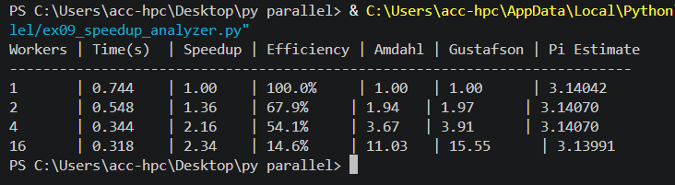

Exercise 10: Build Your Own Parallel Toolkit
Topic: Integrating all Day 1 concepts

Problem Statement
Write a program ex10_parallel_toolkit.py that combines serialization, multiprocessing, threading, and performance measurement into a single cohesive tool.
Scenario: You are building a data processing pipeline that:
- Loads a list of tasks from a JSON configuration file.
- Processes the tasks in parallel using a process pool.
- Saves the results using Pickle.
- Reports performance metrics.
Step-by-Step

Step 1 — Create the task file:
Create a file tasks.json containing:

[
 | {"id": | 1, | "operation": | "sum_of_squares", | "n": | 2000000},
 | {"id": | 2, | "operation": | "sum_of_squares", | "n": | 3000000},
 | {"id": | 3, | "operation": | "sum_of_squares", | "n": | 1500000},
 | {"id": | 4, | "operation": | "sum_of_squares", | "n": | 2500000},
 | {"id": | 5, | "operation": | "sum_of_squares", | "n": | 1000000},
 | {"id": | 6, | "operation": | "sum_of_squares", | "n": | 3500000}
]

Step 2 — Load tasks:
Read the JSON file and parse it into a list of task dictionaries.
Step 3 — Define the worker function:

def execute_task(task):
"""Execute a single task and return the result.""" start = time.time()
# Compute sum of squares from 0 to task["n"] result = sum(i * i for i in range(task["n"])) elapsed = time.time() - start
return {
"id": task["id"],
"n": task["n"],

"result": result,
"time": round(elapsed, 4)
}
Step 4 — Run sequentially and in parallel:
- Sequential: [execute_task(t) for t in tasks]
- Parallel: pool.map(execute_task, tasks)
Step 5 — Save results:
Pickle the list of result dictionaries to results.pkl.

Step 6 — Report:
Print a table showing:
- Each task's ID, n, result, and execution time
- Total sequential time vs parallel time
- Speedup and efficiency
Hints & Guidelines
- This exercise ties together JSON (config loading), Pickle (result persistence), multiprocessing (parallel execution), and performance measurement — all topics from Day 1.
- Start by getting the sequential version working, then add parallelism.
- Use json.load() for input and pickle.dump() for output — this mirrors a common real-world pattern (human-readable config in, machine-efficient results out).

Best Practices
- Separate concerns: loading, processing, saving, and reporting should each be their own function.
- Validate the JSON structure before processing — check that required keys exist.
- Print the speedup only after verifying that sequential and parallel results match.
Code:
import json
import pickle
import time
import multiprocessing
import os

def create_task_file():
tasks = [
{"id": 1, "operation": "sum_of_squares", "n": 2000000},
{"id": 2, "operation": "sum_of_squares", "n": 3000000},
{"id": 3, "operation": "sum_of_squares", "n": 1500000},
{"id": 4, "operation": "sum_of_squares", "n": 2500000},
{"id": 5, "operation": "sum_of_squares", "n": 1000000},
{"id": 6, "operation": "sum_of_squares", "n": 3500000}
]
with open("tasks.json", "w", encoding="utf-8") as f:
json.dump(tasks, f, indent=4)

def execute_task(task):
start = time.time()
result = sum(i * i for i in range(task["n"]))
elapsed = time.time() - start
return {
"id": task["id"],
"n": task["n"],
"result": result,
"time": round(elapsed, 4)
}

if __name__ == "__main__":
create_task_file()

with open("tasks.json", "r", encoding="utf-8") as f:
tasks = json.load(f)

start_seq = time.time()
seq_results = [execute_task(t) for t in tasks]
total_seq_time = time.time() - start_seq

start_par = time.time()
with multiprocessing.Pool() as pool:
par_results = pool.map(execute_task, tasks)
total_par_time = time.time() - start_par

with open("results.pkl", "wb") as f:
pickle.dump(par_results, f)

speedup = total_seq_time / total_par_time if total_par_time > 0 else 0
num_workers = multiprocessing.cpu_count()
efficiency = (speedup / num_workers) * 100

print("Task ID | N | Result | Time (s)")
print("-" * 55)
for res in par_results:
print(f"{res['id']:<7} | {res['n']:<9} | {res['result']:<19} | {res['time']}")

print("-" * 55)
print(f"Total Sequential Time: {total_seq_time:.4f} seconds")
print(f"Total Parallel Time: {total_par_time:.4f} seconds")
print(f"Speedup: {speedup:.2f}x")
print(f"Efficiency: {efficiency:.2f}%")

if os.path.exists("tasks.json"):
os.remove("tasks.json")
if os.path.exists("results.pkl"):
os.remove("results.pkl")

Output:
